**Date: 04.02.2024**

**CS425A: COMPUTER NETWORKS**

**Assignment-1**

**Submitted by:**

Anay Sinhal

EXY23017

**TASK 1:**

**Data Collection**

The experiment involved collecting Received Signal Strength Indicator (RSSI) values at various distances from a Wi-Fi access point named “Hotspot”. The readings obtained were as follows:

|  |  |
| --- | --- |
| **Distance (m)** | **RSSI (dBm)** |
| 0 | -21 |
| 4 | -53 |
| 8 | -60 |
| 12 | -67 |
| 16 | -73 |
| 20 | -78 |
| 24 | -82 |
| 28 | -87 |

**Logarithmic Scale Conversion**

The distances were converted to a logarithmic scale (base 10) to facilitate a linear analysis of the exponential relationship between distance and RSSI values. The table below shows the actual distances, their corresponding logarithmic values, and the RSSI values:

|  |  |  |
| --- | --- | --- |
| **Distance (m)** | **Log10 (Distance)** | **RSSI (dBm)** |
| 0 | 0.00 | -21 |
| 4 | 0.60 | -53 |
| 8 | 0.90 | -60 |
| 12 | 1.08 | -67 |
| 16 | 1.20 | -73 |
| 20 | 1.30 | -78 |
| 24 | 1.38 | -82 |
| 28 | 1.45 | -87 |

**Plotting Data**

The plot visualizes the relationship between log-scaled distances and RSSI values. A best-fit line (shown in red) models this relationship, illustrating how the RSSI decreases as distance increases on a logarithmic scale.

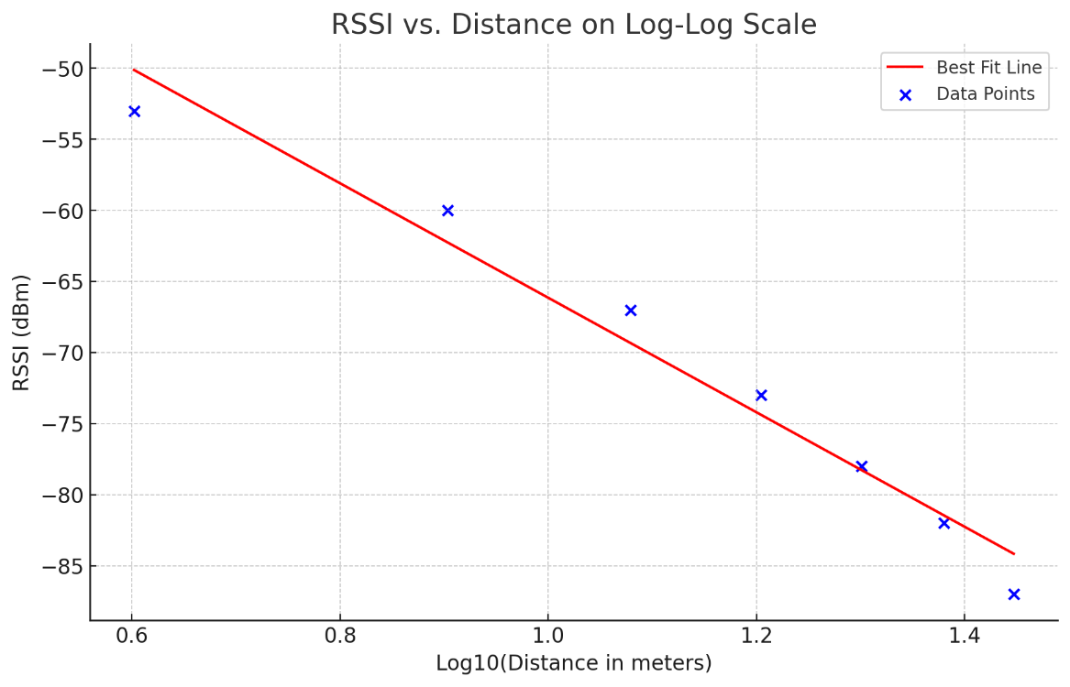

The best-fit line was determined using linear regression analysis. The slope −40.27) and intercept (−25.89) of the line were calculated by fitting a line that minimizes the square of the difference between the observed values and those predicted by the line.

**Path Loss Exponent**

The path loss exponent, n, quantifies the rate at which signal strength decreases with distance. It was calculated as the absolute value of the slope divided by 10:

$$n= \frac{|slope|}{10}= \frac{|-40.27|}{10}=4.03$$

This value indicates a relatively steep decline in signal strength with distance, which is typical in environments with obstacles or interference.

**Variance Calculation**

The variance of the RSSI samples relative to the best-fit line quantifies the variability in the measurements from what the model predicts. It was calculated by comparing the actual RSSI values to those predicted by the best-fit line, resulting in a variance of **4.16**.

This variance highlights the spread of the data points around the predicted values, indicative of measurement noise, environmental factors, or other sources of error not accounted for by the simple path loss model.

**TASK 2:**

**Range Estimation**

The distance d can be estimated from a received signal strength Pr(d) using the formula:

$$\operatorname{Pr}\left(d\right)=\operatorname{Pr}\left(d_{0}\right)-10∙n∙\log_{10}{\frac{d}{d_{0}}}$$

Rearranging the formula to solve for d gives:

$$d= d_{0}×{10}^{\frac{Pr⁡(d_{0})-\operatorname{Pr}\left(d\right)}{10∙n}}$$

where n = 4.03, d0 = 1 meter (reference distance), and Pr(d0) = −21 dBm.

The table below details the actual distances, estimated distances, and the errors between these values:

|  |  |  |
| --- | --- | --- |
| **Actual Distance (m)** | **Estimated Distance (m)** | **Error (m)** |
| 4 | 6.22 | 2.22 |
| 8 | 9.28 | 1.28 |
| 12 | 13.85 | 1.85 |
| 16 | 19.51 | 3.51 |
| 20 | 25.97 | 5.97 |
| 24 | 32.63 | 8.63 |
| 28 | 43.42 | 15.42 |

The average error in distance estimation across these measurements was approximately **5.56 meters**. This reflects the variability and challenges in accurately predicting distances based on RSSI values, primarily due to environmental factors, assumptions in the model, and the approximation used for Pr(d0).